**Volunteer Cattery Assistant**

**Purpose of role:**

***This role supports the work of our Animal Welfare Team. Volunteers in this role will***

***work directly with cats looking for new homes and assist Wadars to maintain a high level of care.***

**Main activities:**

• Cleaning of cat pens and equipment within the pens (eg beds, toys, scratching

posts) and replacing soiled litter trays

• Assisting staff with feeding of cats

• Cleaning of other areas of the cattery, including the kitchen and storage rooms

• To spend time with individual cats to provide stimulation and socialisation

• To get cats used to being groomed & provide enrichment as directed by Wadars

animal welfare staff

**Time commitment:**

• Volunteers will need to be flexible in order to carry out this role as we will operate a rota

system, but Wadars would expect volunteers to complete one three hour shift a week

• Wadars asks that volunteers commit to their role for at least three months

• Volunteers may also be required to commit to attend a training session

**Requirements:**

• You must be aged 18 or over

• Some experience of handling animals would be an advantage

• This can be a physically demanding role and you will be on your feet for up to three hours

at a time

• You must follow Wadars policies and procedures for animal handling/welfare

• You must follow Wadars health and safety policies at all times

• You might be required to undertake follow-up or additional training deemed necessary to

provide appropriate understanding and ability to fulfil the role

**What you will get out of the role:**

• To help create a calm, clean, friendly environment for cats & rabbits in our care

• An insight into the frontline working of Wadars

• Experience of working as part of a highly dedicated team concerned with the welfare of

animals

• Opportunities to get more involved with the work of Wadars

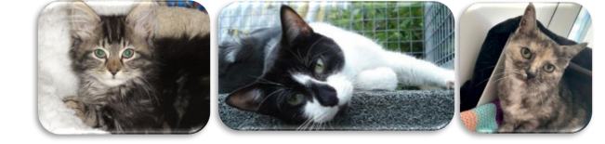

*August 2022 Registered charity number 114988*