*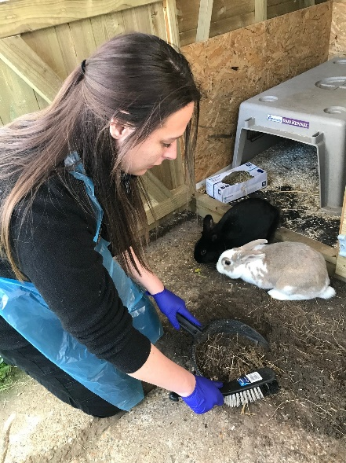***Wadars Small Animal Unit Volunteer**

**Purpose of role:**

***This role supports the work of our Animal Welfare Team. Volunteers in this role will be hands-on with a range of small domestic mammals that are looking for new homes which could include rabbits; guinea pigs; rats; gerbils; hamsters and mice.***

**Main activities:**

* Cleaning out of small animal enclosures and the surrounding area
* Setting up pens ready for small mammals, including providing enrichment for them
* Assisting Wadars staff with feeding of the small mammals
* Spending time with individual rabbits to provide them with stimulation and socialisation
* Grooming rabbits to help keep their coats healthy
* Moving rabbits from their enclosures out to grass pens
* Daily record keeping in order to help monitor each animal’s health and welfare
* Other general cleaning tasks including washing up, sweeping, organising stock

**Time commitment:**

* Each shift will be approximately three to four hours, starting at 8.30am
* Wadars asks that volunteers commit to their role for a minimum of three months
* All volunteers will be asked to attend a training session related to their chosen role
* Volunteers are required to give as much notice as possible if unable to attend a planned shift

**Requirements:**

* Volunteers must be at least 18 years of age
* Some experience of handling animals will be an advantage
* Volunteers must follow Wadars’ policies and procedures for animal handling/welfare
* 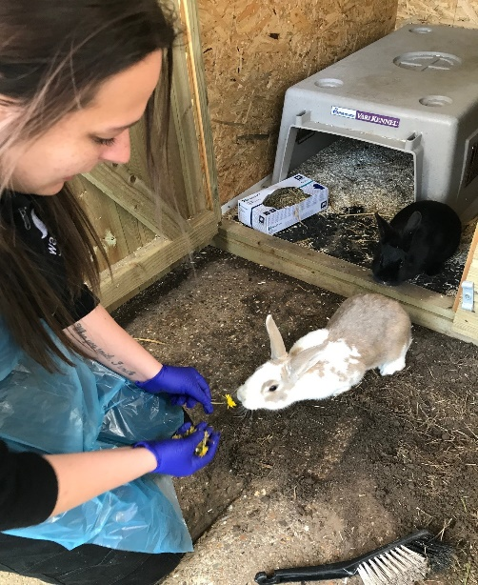Volunteers must follow Wadars’ health & safety policies at all times

**What you will get from volunteering in the Small Animal Unit:**

* An insight into frontline animal rescue work
* The experience of working as part of a team which is dedicated to delivering the best care and welfare for animals
* An opportunity to meet other like-minded people
* Opportunities to get involved in other aspects of the Charity’s work

**Please be aware:**

***This role can be physically demanding and will involve a fair amount of bending and stretching whilst cleaning out enclosures. In addition to handling the animals, volunteers will be in close contact with hay, straw, and other bedding materials. Appropriate PPE will be provided to anyone working in the small animal unit.***

Wadars registered charity number 1149884.